**GANPAT UNIVERSITY**

**U.V.PATEL COLLEGE OF ENGINEERING & TECHNOLOGY**

**Department of Computer Science and Engineering**

**B.Tech 1ST Semester   Subject – ESFP**

**First Name: Parth Patel       Enrollment Number:t14012101006                Stream :CBA**

**Practical – 2                                                                                 Date:27/08/2014**

1. Write a program to print ASCII values of all backslash characters and white space on screen in following format :

The ASCII value of ‘\t’ is : 9

(Hint : you can verify your ASCII values with the help of a table for ASCII values from text book)

2. Explain different data types available in C.

3. Explain about C Tokens in brief.

4. Explain about backslash characters in C.

Answers:-

A1)

Code:-

#include<stdio.h>

#include<conio.h>

void main()

{

char a,b,c,d,e,f,g,h,i,j,k,l,m;

a='\a';

b='\b';

c='\f';

d='\n';

e='\r';

f='\t';

g='\v';

h='\\';

i='\'';

j='\"';

k='\?';

l='\N';

m='\XN';

clrscr();

printf("\nThe Ascii value of \\a is :%d",a);

printf("\nThe Ascii value of \\b is :%d",b);

printf("\nThe Ascii value of \\f is :%d",c);

printf("\nThe Ascii value of \\n is :%d",d);

printf("\nThe Ascii value of \\r is :%d",e);

printf("\nThe Ascii value of \\t is :%d",f);

printf("\nThe Ascii value of \\v is :%d",g);

printf("\nThe Ascii value of \\\ is :%d",h);

printf("\nThe Ascii value of \\' is :%d",i);

printf("\nThe Ascii value of \\\" is :%d",j);

printf("\nThe Ascii value of \\\? is :%d",k);

printf("\nThe Ascii value of \\N is :%d",l);

printf("\nThe Ascii value of \\XN is :%d",m);

getch();

}

Screenshot:-

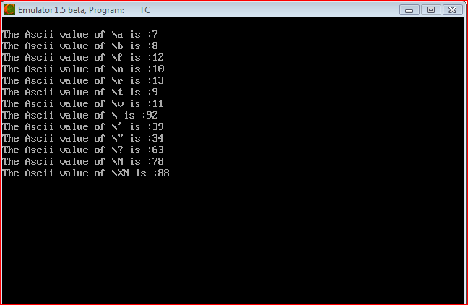

A2)

In C, variable(data) should be declared before it can be used in program. Data types are the keywords, which are used for assigning a type to a variable.

Data types in C:-

1. Fundamental Data Types
   * Integer
   * Floating
   * Character
2. Derived Data Types
   * Arrays
   * Pointers
   * Structures
   * Enumeration

* Integer Data Type:-
* Keyword int is used for declaring the variable with integer type.
* The size of int is either 2 bytes(In older PC's) or 4 bytes. If you consider an integer having size of 4 byte( equal to 32 bits), it can take 232 distinct states as: -231,-231+1, ...,-2, -1, 0, 1, 2, ..., 231-2, 231-1
* Similarly, int of 2 bytes, it can take 216 distinct states from -215 to 215-1. If you try to store larger number than 231-1, i.e,+2147483647 and smaller number than -231, i.e, -2147483648,  program will not run correctly.

|  |  |  |
| --- | --- | --- |
| **Type** | **Storage size** | **Value range** |
| char | 1 byte | -128 to 127 or 0 to 255 |
| unsigned char | 1 byte | 0 to 255 |
| signed char | 1 byte | -128 to 127 |
| int | 2 or 4 bytes | -32,768 to 32,767 or -2,147,483,648 to 2,147,483,647 |
| unsigned int | 2 or 4 bytes | 0 to 65,535 or 0 to 4,294,967,295 |
| short | 2 bytes | -32,768 to 32,767 |
| unsigned short | 2 bytes | 0 to 65,535 |
| Long | 4 bytes | -2,147,483,648 to 2,147,483,647 |
| unsigned long | 4 bytes | 0 to 4,294,967,295 |

* **Floating point data type:**

Floating point data type consists of 2 types. They are,

* 1. float
  2. double

**1. float:**

* Float data type allows a variable to store decimal values.
* Storage size of float data type is 4. This also varies depend upon the processor in the CPU as “int” data type.
* We can use up-to 6 digits after decimal using float data type.
* For example, 10.456789 can be stored in a variable using float data type.

**2. double:**

* Double data type is also same as float data type which allows up-to 10 digits after decimal.
* The range for double datatype is from 1E–37 to 1E+37.
* Difference between float and double:-

Generally the size of float(Single precision float data type) is 4 bytes and that of double(Double precision float data type) is 8 bytes. Floating point variables has a precision of 6 digits whereas the the precision of double is 14 digits.

* Character types:-

Keyword char is used for declaring the variable of character type. For example:

char var4='h';

Here, *var4* is a variable of type character which is storing a character 'h'.

The size of char is 1 byte. The character data type consists of ASCII characters. Each character is given a specific value.

A2)

**C tokens:**

* + C tokensare the basic buildings blocks in C language which are constructed together to write a C program.
  + Each and every smallest individual units in a C program are known as C tokens.
  + C tokens are of six types. They are,
    - 1. Keywords               (eg: int, while),
      2. Identifiers               (eg: main, total),
      3. Constants              (eg: 10, 20),
      4. Strings                    (eg: “total”, “hello”),
      5. Special symbols  (eg: (), {}),
      6. Operators              (eg: +, /,-,*)

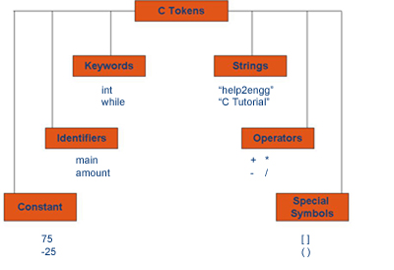

A3)

Backslash Characters:-

1. Although it consists of two characters, it represents single character.

2. Each escape sequence has a unique ASCII value.

3. Each and every combination starts with back slash ”\”.

4. They are not printable characters.

5. It can also be expressed in octal digits as well as hexadecimal sequence.

6. Escape sequence in character constant and string literals are replaced by their equivalent and then adjacent string literals are concatenated.

7. Escape sequences are preprocessed by the Preprocessor.